Import Fujitsu Historical Cases

# Overview

This is the process to bulk import historical and live Fujitsu cases into the system. The system will attempt to find cases that match the HEAT ID (used by the Fujitsu Helpdesk) and update them if it finds a match, and create new cases if there is no matching case with a heat ID.

A User will require permissions to use the **Dynamics Data Import tool**, have access to the **Fujitsu Case Import** **entity** via security roles, have access to (and be using) the Web Interface - not the NGN App.

# Instructions

1. **N****avigate to** **Dynamics CRM Web Interface (“Dynamics 365 – custom”)**
   1. Click the down arrow beside Ministry of Education
   2. Select “Dynamics 365 – custom

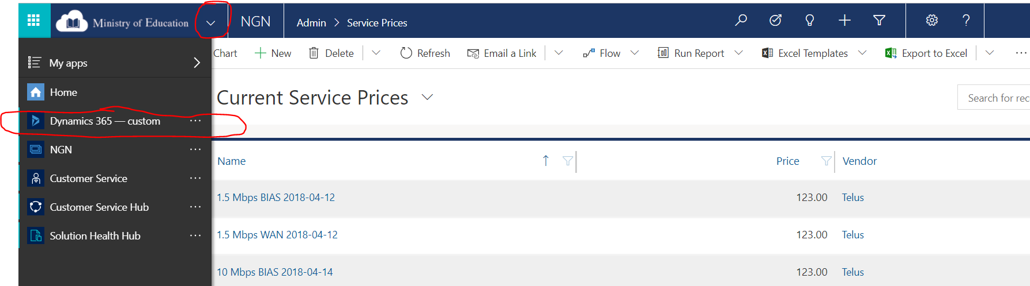

1. **Go to Data Management section**
   1. Select Settings
   2. Select Data Management

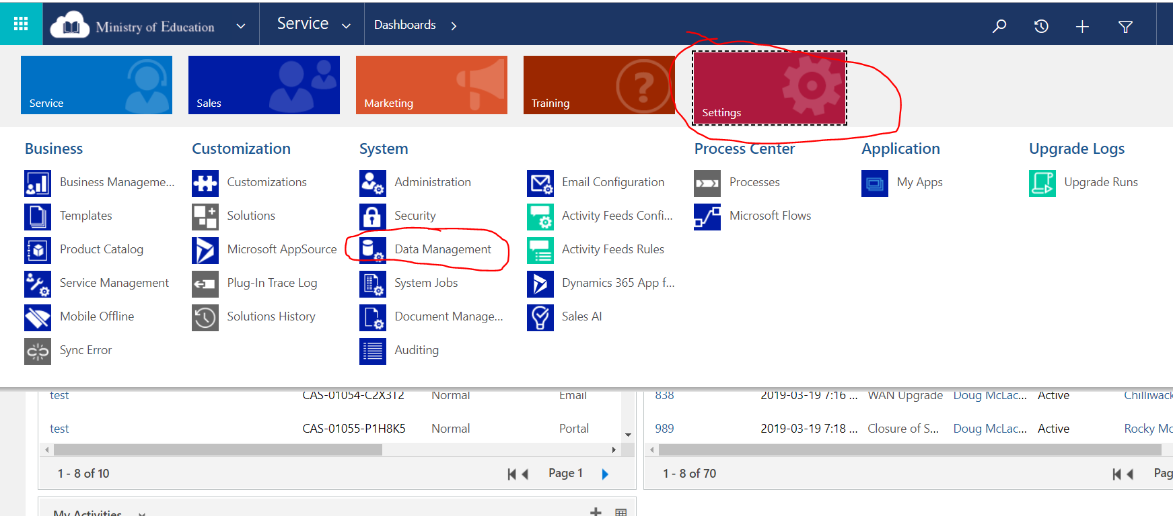

1. **Get a template for Fujitsu Case Import**
   1. Select “Templates for Data Import” 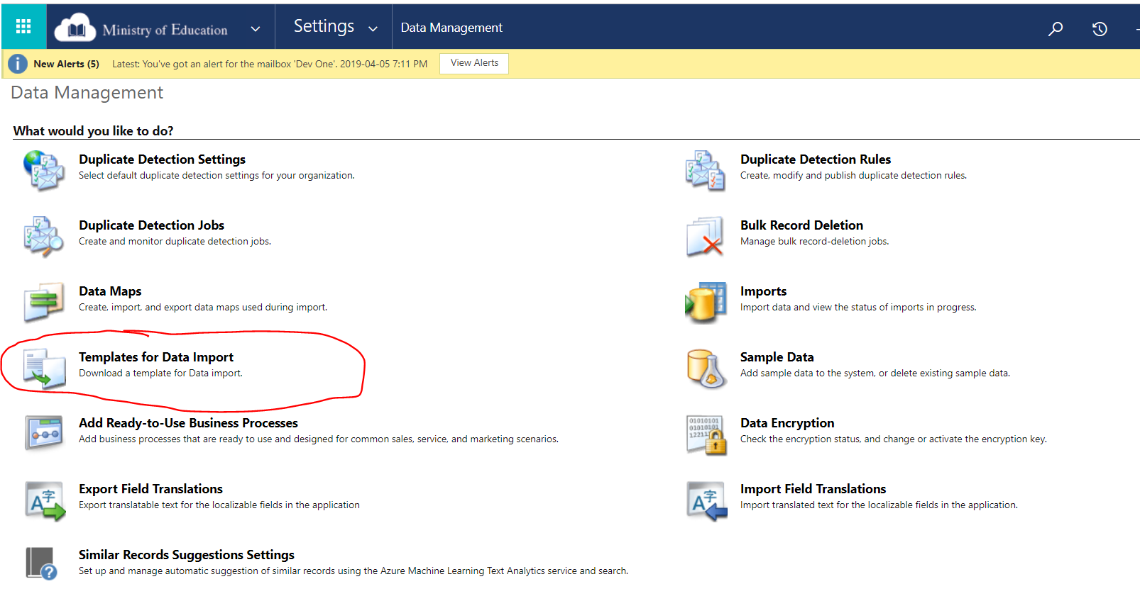
   2. Select “Fujitsu Case Import”

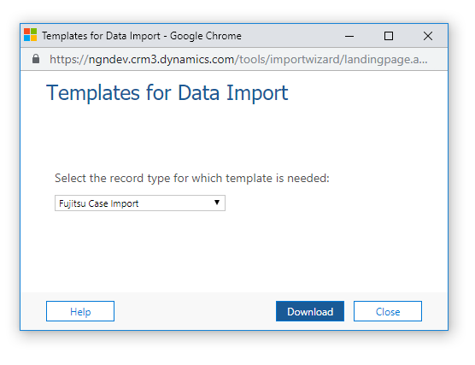

* 1. Click Download

1. **Fill in the excel document**
   1. Enable Editing if needed (yellow box on top of excel document)
   2. Do not add or remove columns from the import file – there are hidden columns which dynamics uses which must be unchanged.
   3. Enter the following Fields:
      * **Incident** – the Heat ID
      * **Category** – The Fujitsu Category
      * **Sub-Category** – The Fujitsu Sub-Category
      * **Created On** – The date created of the Fujitsu Case (yyyy-mm-dd recommended)
      * **Location** – The School District Name and ID
      * **PLNet Vendor** – the Vendor
      * **Closed Date** – The date the Fujitsu Case was closed (yyyy-mm-dd recommended)
   4. Leave the following fields blank:
      * **Case**
      * **Owner**
      * **Name**
      * **Import** **Status**
   5. Save the file
2. **Import the File**
   1. Select Imports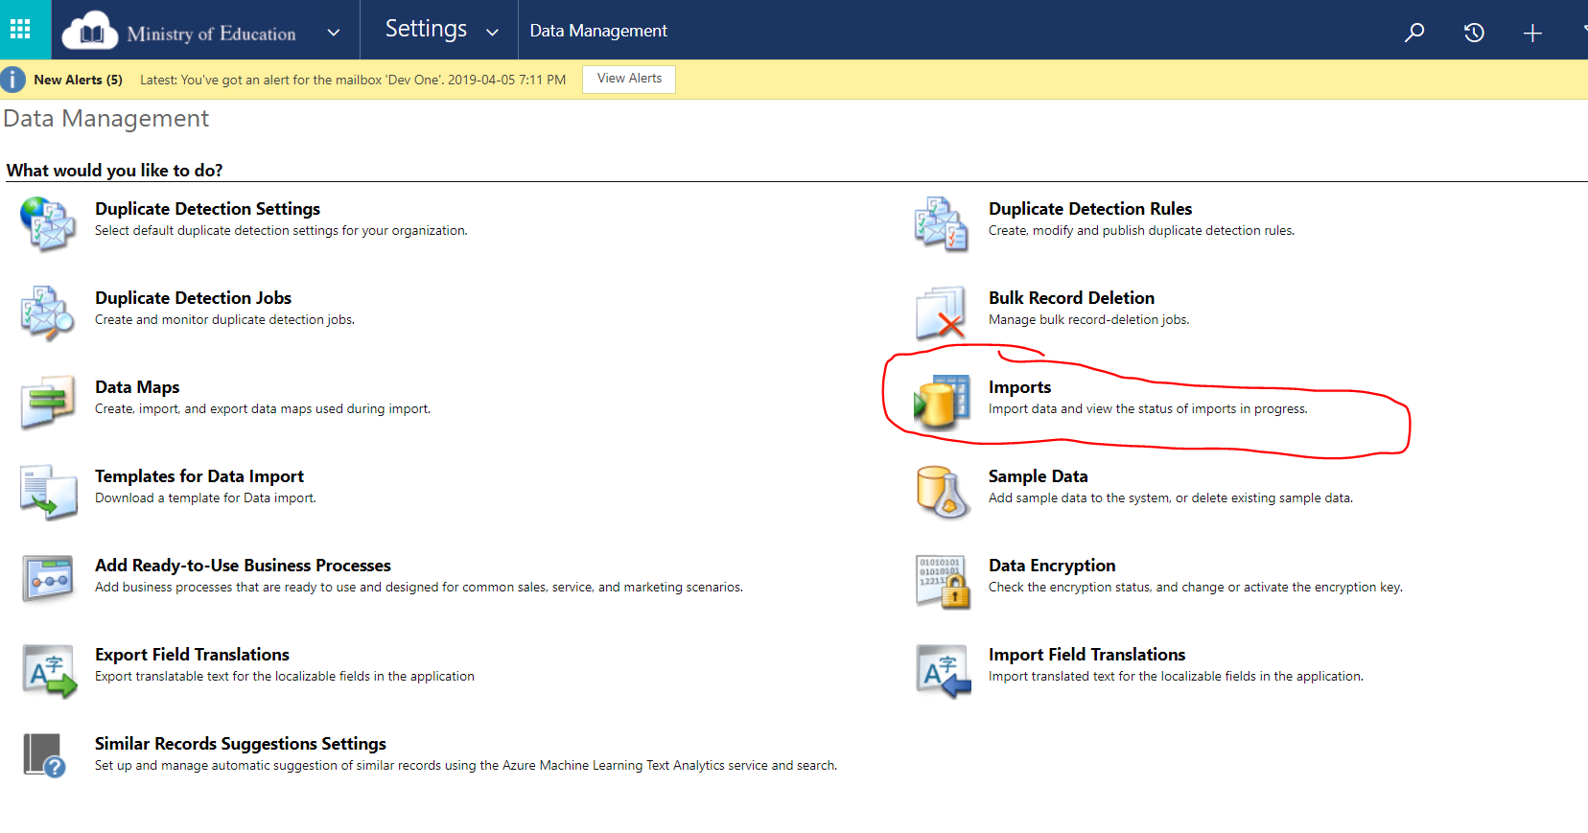
   2. Click Import Data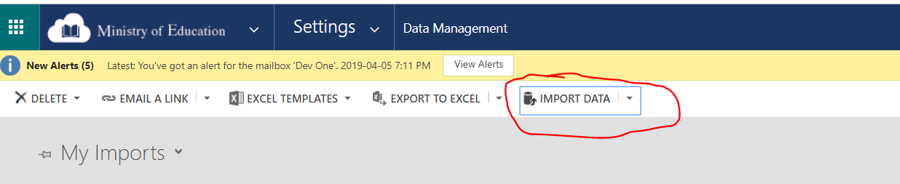
   3. Select your file and click Next

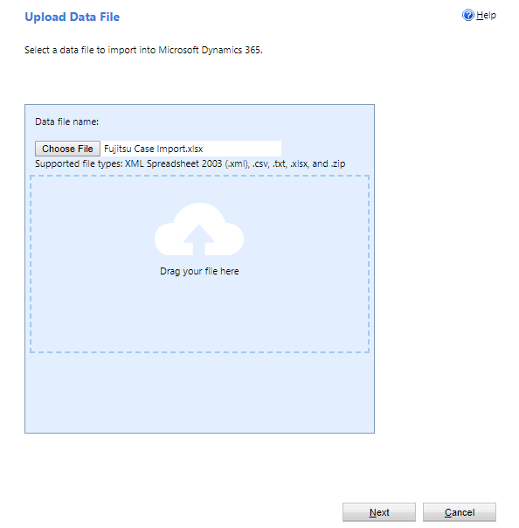

* 1. Click Submit
  2. Click Finish

1. **Check Import Success**
   1. 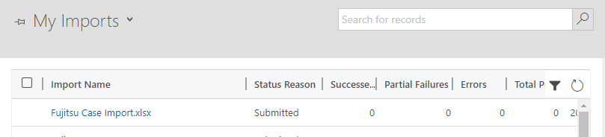Your import will be displayed under the **My Imports** view with a status of **Submitted**. It will take a few minutes to complete.
   2. Click the refresh button to see the updated status.
   3. If the Import failed, double click on the Import record to find out why

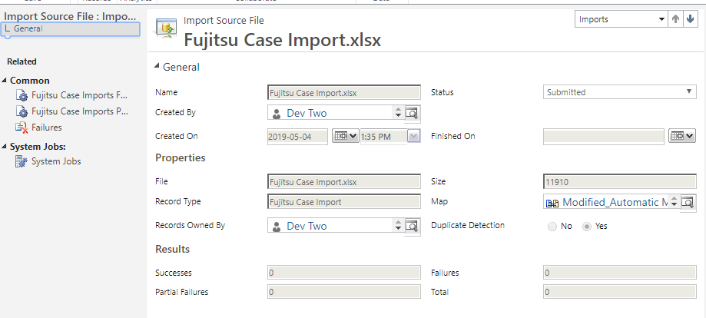

# Troubleshooting

1. Follow step #6 to check if the import worked.
2. Then double click on the import record and select either “Failed” or “Service Prices Partially Imported” on the left side of the screen.

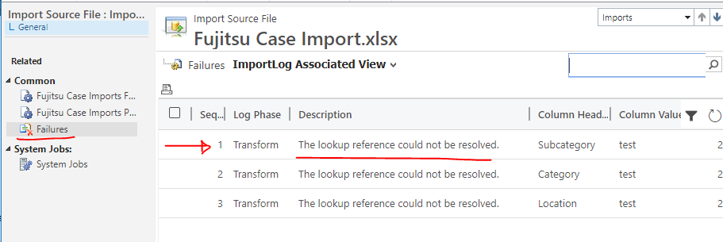

1. For Failed records
   1. Most likely you will see a message saying “The lookup reference couldn’t be resolved” and a Column Heading of Category, Sub-Category, or Current Case. This means it couldn’t find a matching record.
   2. Double check your spelling and create a new import file with **only these failed records**.
2. For Partially Imported records
   1. Review what the error is
   2. Manually update the partially imported record